Beithir User Manual v1
Beithir is intended to aid in writing the tab-delimited (TSV) procedure files used for the Opentrons ddPCR, PCR, and NGS indexing programs. The program opens to a splash screen with “File”, “Modules”, and “Help” in the top left.

File
- Save will save the current active template as a TSV file.
- Exit will close the program without saving the data.

Modules
- Home will display the splash screen
- ddPCR
- Illumina Dual Indexing

ddPCR
Used to create a ddPCR TSV file. Figure 1 shows the initial ddPCR screen. The version number field is not editable; it is fixed to the Opentrons program. All the other fields on this form except the --UseTemperatureModule checkbox, must have a value.

Required Parameters
Field Name | Data
--Name | Enter your name or initials. The robot uses this value.
--Run_Date | Select data of ddPCR run or date of form.
--LeftPipetteFirstTip | Location of first tip in first tip box associated with left pipette. Default is A1
--RighgPipetteFirstTip | Location of first tip in first tip box associated with right pipette. Default is A1
--BottomOffset | Value in millimeters to raise pipette tip from bottom of well. Must be a float. Default is 1.0
--Temperature | If --UseTemperatureModule is selected, enter a temperature value between 3 and 95℃ for the temp module. Float such as 4.0.
--PCR_PlateSlot | Slot location of destination PCR plate. Integer (1,2,3,4,5,6,7,8,9,10,11)
--DilutionPlateSlot | Slot location of dilution tubes or plate. Integer (1,2,3,4,5,6,7,8,9,10,11)
--ReagentSlot | Slot location of labware holding Reagents. Integer (1,2,3,4,5,6,7,8,9,10,11)
--WaterResWell | Well location of tube holding water in reagent slot. A1,A2,B1.....
--WaterResVol | How much water, in µL, is in the water tube. Integer or Float. Total cannot exceed maximum tube volume.
--PCR_Volume | Volume of PCR in µL in destination well. Float. Default is 25.0
--MasterMixPerRxn | How much master mix to dispense into each well.
--DNA_in_Reaction | How many ng of DNA per well. Float.

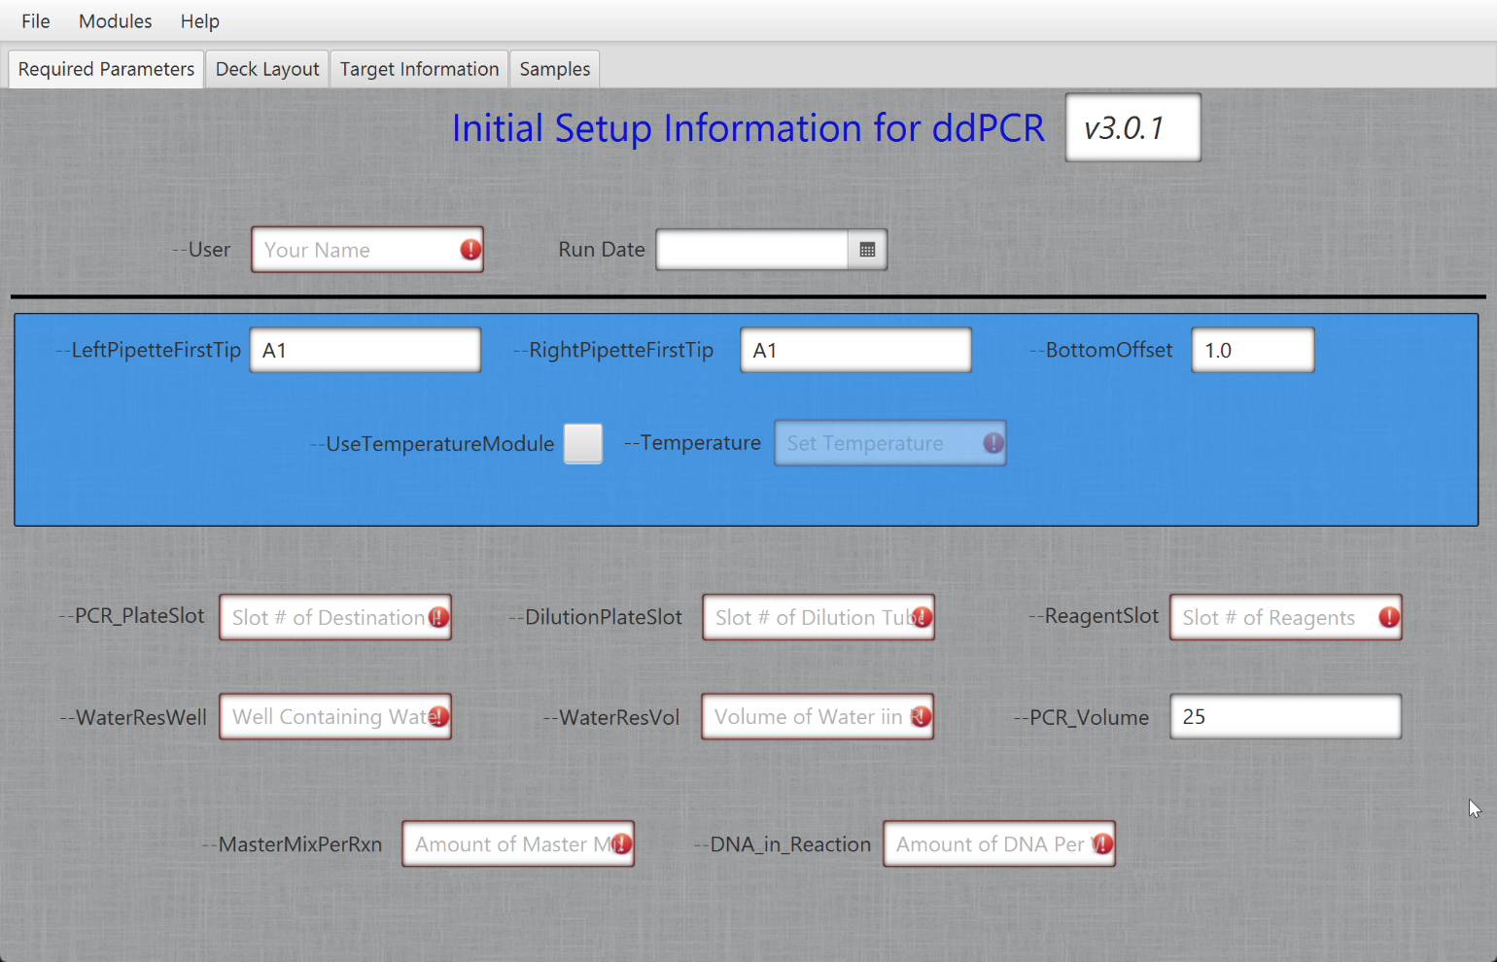
Figure 1. Initial ddPCR Screen

Deck Layout
Figure 2 shows the Deck Layout tab. Each of these is a dropdown list showing the available labware for the robot. Select the labware for each slot. It is up to the user to understand which slot is compatible with which labware and which labware cannot be placed next to which.
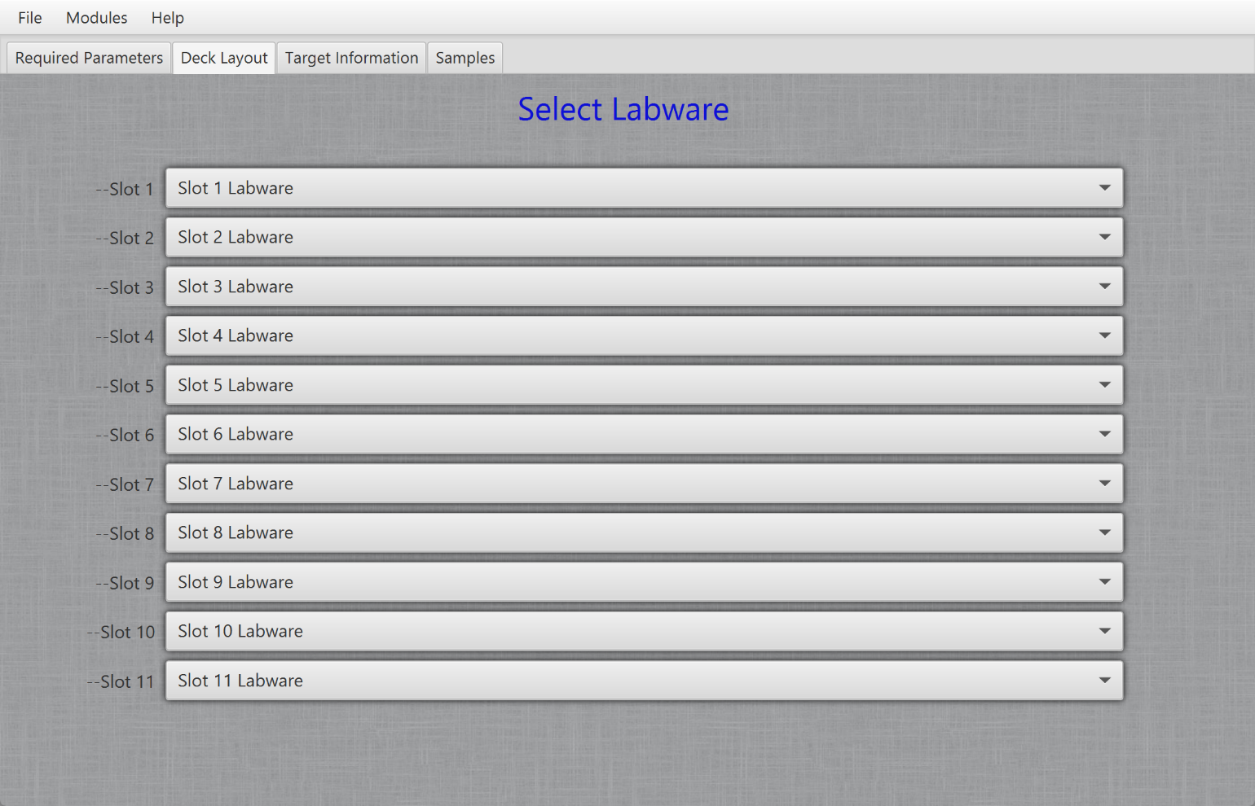
Figure 2. Deck layout selection

Target Information
Figure 3 shows the fields for entering the target information. The targets are in the labware in the Reagent Slot. At least one target must be defined.
Field Name | Data
Target Name | Required, any value to help identify the target. This is used for the plate layout file.
Target Well | Well in reagent labware. A1, A2, B1....
Target Volume | Amount of target in tube in µL. Float

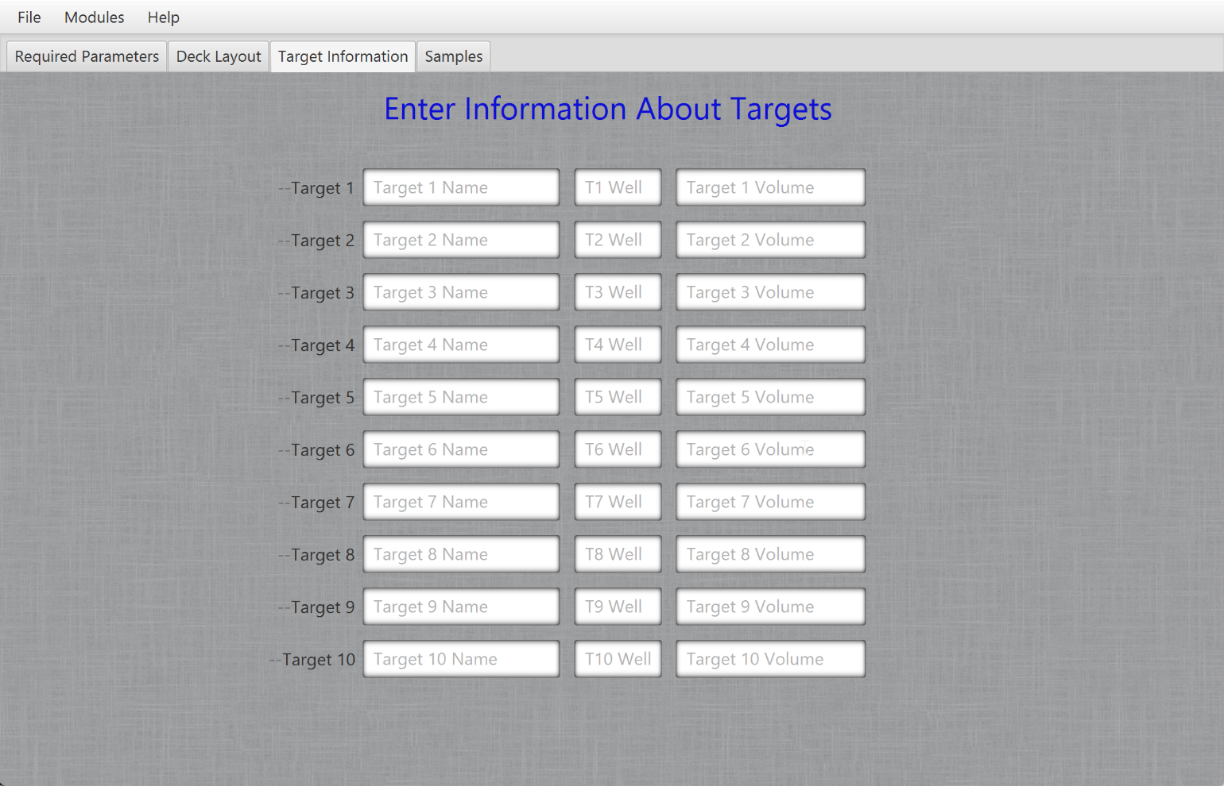
Figure 3. Target Information

Samples
Enter information about the samples. This page does not flow easily. Only one sample at a time can be entered. For each sample, the slot, well, name, concentration, targets, and replicas are entered (Figure 4.). Once these fields are filled out, click the “Add Sample Information” button. This will add the fields to the sample table. It is faster to enter just one sample then, after creating the TSV file, paste the remaining samples in from an Excel table.

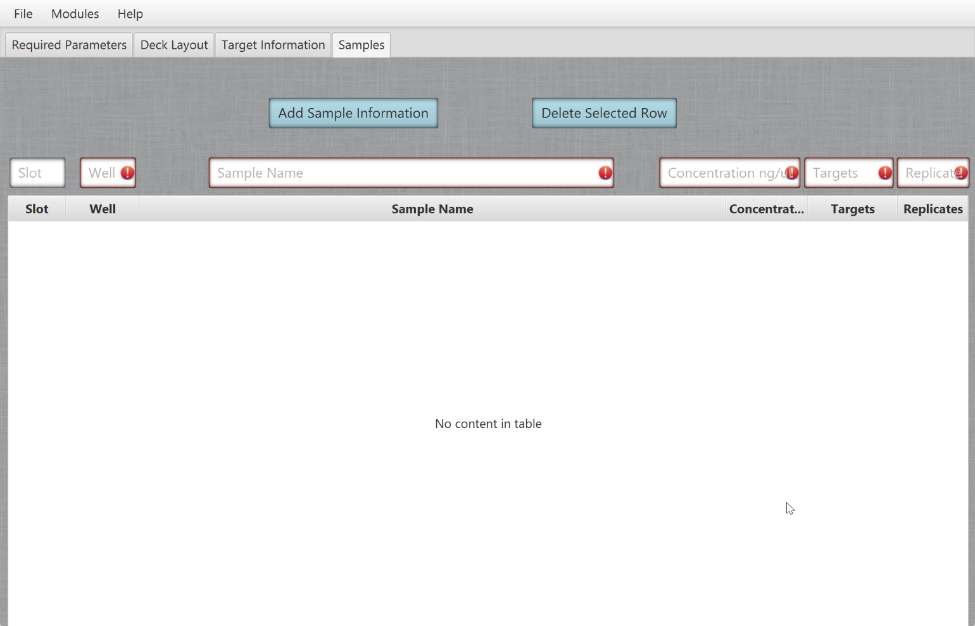
Figure 4. Sample data entry.

Illumina Dual Indexing

Required Parameters
This takes the same information as the ddPCR Required Parameters shown in Figure 1.

Deck Layout
This takes the same information as the ddPCR Deck Layout shown in Figure 2.

Indexing Primers
--IndexPrimerSlot field sets the location of the labware containing the Indexing Primers (Figure 5). Nothing else can go in this slot. The default values for the wells are the recommended locations for the individual tubes.
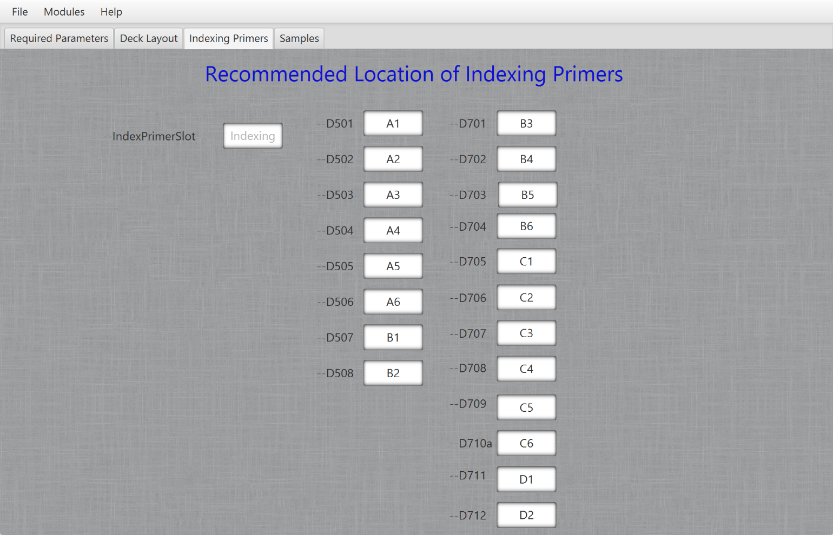
Figure 5. Location of Indexing Primers

Samples
The table describing the samples is the same as the Samples table for ddPCR (Figure 4.)

